Airline Flight Booking System

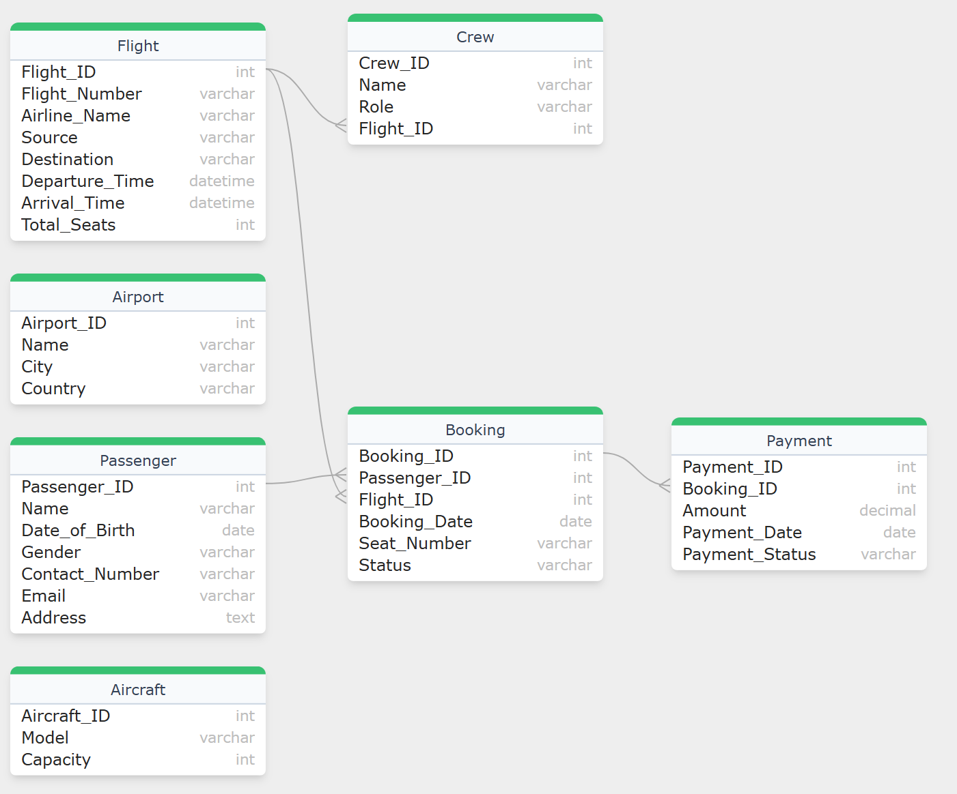

Submitted by,

Anissha M

-- creating data base

CREATE DATABASE project;

-- using the db

use project;

-- creating the table passenger

CREATE TABLE Passenger(

Passenger_ID INT PRIMARY KEY,

Name VARCHAR(100),

Date_of_Birth DATE,

Gender VARCHAR(10),

Contact_Number VARCHAR(15),

Email VARCHAR(100),

Address TEXT);

-- insert values into passenger

INSERT INTO Passenger(Passenger_ID, Name, Date_of_Birth, Gender, Contact_Number, Email, Address)

VALUES

(101, 'John Doe', '1995-08-15', 'Male', '1-987-654-3210', 'john@example.com', '123 Main Street, New York, NY 10001, USA'),

(102, 'David Frank', '2000-03-25', 'Male', '44-7654-321-987', 'david@example.com', '456 Elm Avenue, Los Angeles, CA 90012, USA'),

(103, 'Sam Noel', '1987-12-10', 'Male', '91-98765-43210', 'sam@example.com', '789 Oak Road, Toronto, ON M5H 2N2, Canada'),

(104, 'Anny Frank', '1992-06-30', 'Female', '61-412-345-678', 'anny@example.com', '101 Maple Drive, London SW1A 1AA, UK'),

(105, 'Daniel William', '1985-11-05', 'Male', '49-170-1234567', 'daniel@example.com', '202 Cherry Lane, Sydney, NSW 2000, Australia'),

(106, 'Swamy Nathan', '1998-04-20', 'Male', '33-612-345-678', 'swamy@example.com', '303 Pine Street, Mumbai, MH 400001, India'),

(107, 'Xavier Bob', '2003-09-12', 'Male', '81-90-1234-5678', 'xavier@example.com', '404 Birch Avenue, Berlin 10115, Germany'),

(108, 'Theresa Vinsent', '1990-07-01', 'Female', '55-21-98765-4321', 'theresa@example.com', '505 Cedar Boulevard, Tokyo 100-0001, Japan'),

(109, 'Anna John', '1982-10-18', 'Female', '27-82-123-4567', 'anna@example.com', '606 Willow Court, Cape Town 8001, South Africa'),

(110, 'Kale Paul', '2005-02-28', 'Male', '86-138-7654-3210', 'kale@example.com', '707 Spruce Crescent, São Paulo 01000-000, Brazil');

ALTER TABLE Passenger

Modify column Contact_Number VARCHAR(70);

-- displaying the content

SELECT * FROM Passenger;

-- creating table flight

CREATE TABLE Flight (

Flight_ID INT PRIMARY KEY,

Flight_Number VARCHAR(10),

Airline_Name VARCHAR(50),

Source VARCHAR(50),

Destination VARCHAR(50),

Departure_Time DATETIME,

Arrival_Time DATETIME,

Total_Seats INT);

-- insert values into flight

INSERT INTO Flight(Flight_ID, Flight_Number, Airline_Name, Source, Destination, Departure_Time, Arrival_Time, Total_Seats)

VALUES

(1001, 'AI101', 'Air India', 'New York', 'London', '2024-06-10 23:00:00', '2024-06-11 01:00:00', 20),

(1002, 'AI102', 'SkyJet Airways', 'USA', 'Delhi', '2024-09-22 13:00:00', '2024-09-23 12:00:00', 26),

(1003, 'AI103', 'Global Wings', 'Bangalore', 'Chennai', '2024-10-13 07:00:00', '2024-10-14 08:00:00', 200),

(1004, 'AI104', 'AeroVista Airlines', 'Indonnasia', 'Chennai', '2024-11-30 03:00:00', '2024-12-01 04:00:00', 167),

(1005, 'AI105', 'Cloud Nine Air', 'Coimbatore', 'Bangalore', '2024-07-04 04:00:00', '2024-07-05 05:00:00', 123),

(1006, 'AI106', 'SwiftAir Express', 'Delhi', 'Bangkok', '2024-05-01 05:00:00', '2024-05-02 06:00:00', 16),

(1007, 'AI107', 'EagleFly Aviation', 'Delhi', 'Ahmedabad', '2024-01-28 06:00:00', '2024-01-29 07:00:00', 11),

(1008, 'AI108', 'Sunrise Airlines', 'France', 'Germany', '2024-03-29 10:00:00', '2024-03-30 11:00:00', 25),

(1009, 'AI109', 'NovaJet Airways', 'Africa', 'South Korea', '2024-12-31 11:00:00', '2025-01-01 12:00:00', 60),

(1010, 'AI110', 'Infinity Air', 'Khazakastan', 'Coimbatore', '2024-08-09 12:00:00', '2024-08-10 13:00:00', 100);

-- displaying the content

SELECT * FROM Flight;

-- creating table booking

CREATE TABLE Booking (

Booking_ID INT PRIMARY KEY,

Passenger_ID INT,

Flight_ID INT,

Booking_Date DATE,

Seat_Number VARCHAR(5),

Status VARCHAR(20) CHECK (Status IN ('Confirmed', 'Canceled', 'Pending')),

FOREIGN KEY (Passenger_ID) REFERENCES Passenger(Passenger_ID),

FOREIGN KEY (Flight_ID) REFERENCES Flight(Flight_ID));

-- insert values into booking

INSERT INTO Booking(Booking_ID, Passenger_ID, Flight_ID, Booking_Date, Seat_Number, Status)

VALUES

(201, 101, 1001, '2024-10-01', '08J', 'Confirmed'),

(202, 102, 1002, '2024-09-02', '10P', 'Canceled'),

(203, 103, 1003, '2024-08-03', '17U', 'Confirmed'),

(204, 104, 1004, '2024-07-04', '03I', 'Pending'),

(205, 105, 1005, '2024-06-05', '39F', 'Confirmed'),

(206, 106, 1006, '2024-05-06', '44Q', 'Pending'),

(207, 107, 1007, '2024-04-07', '38B', 'Canceled'),

(208, 108, 1008, '2024-03-08', '09R', 'Confirmed'),

(209, 109, 1009, '2024-02-09', '49L', 'Canceled'),

(210, 110, 1010, '2024-01-10', '50A', 'Confirmed');

-- displaying the content

SELECT * FROM Booking;

-- creating table payment

CREATE TABLE Payment (

Payment_ID INT PRIMARY KEY,

Booking_ID INT,

Amount INT,

Payment_Date DATE,

Payment_Status VARCHAR(80) CHECK (Payment_Status IN ('Paid', 'Pending', 'Failed')),

FOREIGN KEY (Booking_ID) REFERENCES Booking(Booking_ID));

-- inserting the values

INSERT INTO Payment(Payment_ID, Booking_ID, Amount, Payment_Date, Payment_Status)

VALUES

(301, 201, 1500, '2024-09-01', 'Paid'),

(302, 202, 2500, '2024-08-02', 'Paid'),

(303, 203, 3500, '2024-07-03', 'Paid'),

(304, 204, 4500, '2024-06-04', 'Paid'),

(305, 205, 2500, '2024-05-05', 'Paid'),

(306, 206, 1500, '2024-04-06', 'Paid'),

(307, 207, 2500, '2024-03-07', 'Paid'),

(308, 208, 7500, '2024-02-08', 'Paid'),

(309, 209, 3500, '2024-01-09', 'Paid'),

(310, 210, 7500, '2024-11-10', 'Paid');

-- displaying the content

SELECT * FROM Payment;

-- creating table airpot

CREATE TABLE Airport (

Airport_ID INT PRIMARY KEY,

Name VARCHAR(100),

City VARCHAR(50),

Country VARCHAR(50));

-- inserting values

INSERT INTO Airport (Airport_ID, Name, City, Country)

VALUES

(1, 'John F. Kennedy International Airport', 'New York', 'USA'),

(2, 'Los Angeles International Airport', 'Los Angeles', 'USA'),

(3, 'Heathrow Airport', 'London', 'UK'),

(4, 'Charles de Gaulle Airport', 'Paris', 'France'),

(5, 'Dubai International Airport', 'Dubai', 'UAE'),

(6, 'Tokyo Haneda Airport', 'Tokyo', 'Japan'),

(7, 'Sydney Kingsford Smith Airport', 'Sydney', 'Australia'),

(8, 'Chhatrapati Shivaji Maharaj International Airport', 'Mumbai', 'India'),

(9, 'Frankfurt Airport', 'Frankfurt', 'Germany'),

(10, 'Singapore Changi Airport', 'Singapore', 'Singapore');

-- displaying the content

SELECT* FROM Airport;

-- creating the table aircraft

CREATE TABLE Aircraft (

Aircraft_ID INT PRIMARY KEY,

Model VARCHAR(50),

Capacity INT);

-- inserting values

INSERT INTO Aircraft(Aircraft_ID, Model, Capacity)

VALUES

(111, 'Boeing 737', 189),

(222, 'Airbus A320', 180),

(333, 'Boeing 777', 396),

(444, 'Airbus A350', 440),

(555, 'Boeing 787', 296),

(666, 'Airbus A380', 850),

(777, 'Embraer E190', 114),

(888, 'Bombardier CRJ900', 90),

(999, 'Boeing 747', 524),

(1010, 'Airbus A321', 244);

-- displaying the content

SELECT * FROM Aircraft;

-- creating table crew

CREATE TABLE Crew (

Crew_ID INT PRIMARY KEY,

Name VARCHAR(100),

Role VARCHAR(50),

Flight_ID INT,

FOREIGN KEY (Flight_ID) REFERENCES Flight(Flight_ID));

-- inserting values

INSERT INTO Crew (Crew_ID, Name, Role, Flight_ID)

VALUES

(1, 'John Smith', 'Pilot', 1001),

(2, 'Sarah Johnson', 'Co-Pilot', 1002),

(3, 'Michael Brown', 'Flight Attendant', 1003),

(4, 'Emily Davis', 'Flight Attendant', 1004),

(5, 'David Wilson', 'Pilot', 1005),

(6, 'Emma Martinez', 'Co-Pilot', 1006),

(7, 'James Taylor', 'Flight Attendant', 1007),

(8, 'Olivia Anderson', 'Flight Attendant', 1008),

(9, 'William Thomas', 'Pilot', 1009),

(10, 'Sophia White', 'Co-Pilot', 1010);

-- displaying the content

SELECT * FROM Crew;

-- retrieve flight details

SELECT * FROM Flight WHERE Source = 'New York' AND Destination = 'London';

-- get booking details for a passenger

SELECT b.Booking_ID, p.Name, f.Flight_Number, f.Airline_Name, f.Source, f.Destination, b.Booking_Date, b.Seat_Number, b.Status

FROM Booking b

JOIN Passenger p ON b.Passenger_ID = p.Passenger_ID

JOIN Flight f ON b.Flight_ID = f.Flight_ID

WHERE p.Passenger_ID = 101;

-- find available flights between two locations

SELECT Flight_Number, Airline_Name, Departure_Time, Arrival_Time, Total_Seats

FROM Flight

WHERE Source = 'Coimbatore' AND Destination = 'Bangalore';

-- getting payment details for a specific booking

SELECT p.Payment_ID, b.Booking_ID, p.Amount, p.Payment_Date, p.Payment_Status

FROM Payment p

JOIN Booking b ON p.Booking_ID = b.Booking_ID

WHERE b.Booking_ID = 210;

-- listing all pending bookings

SELECT * FROM Booking WHERE Status = 'Pending';

-- update booking status

UPDATE Booking

SET Status = 'Confirmed'

WHERE Booking_ID = 206;

-- getting flights departing

SELECT * FROM Flight

WHERE Departure_Time BETWEEN '2024-06-10 23:00:00' AND '2025-01-01 12:00:00';

-- find the most popular flight based on bookings

SELECT f.Flight_ID, f.Flight_Number, f.Airline_Name, COUNT(b.Booking_ID) AS Total_Bookings

FROM Flight f

JOIN Booking b ON f.Flight_ID = b.Flight_ID

GROUP BY f.Flight_ID, f.Flight_Number, f.Airline_Name

ORDER BY Total_Bookings DESC

LIMIT 1;